


IOT for AI PROJECT REPORT

PROJECT TOPIC
Smart Plant care System Using Soil Moisture Sensor and GSM Module

Student Information
Department: School of Engineering & Technology (SET)
Program: CSE Specialization
Class- 6 AIML B
Subject: IoT for AI
Subject Code: BCS-DS-635
Team Members
- Prateek Sharma
Roll No: 1/23/SET/BCS/579
- Dhruv Singh
Roll No: 1/23/SET/BCS/459
- Dhruv Saini
Roll No: 1/23/SET/BCS/458
- Samridh Singh
Roll No: 1/23/SET/BCS/461

Significance of the Project
Agriculture is highly dependent on water availability and proper irrigation. Traditional irrigation methods often lead to excessive water usage or insufficient watering due to lack of monitoring. The Smart Irrigation System is designed to automate irrigation using sensors and microcontrollers.
This project uses a soil moisture sensor to detect the moisture level in soil. When the soil becomes dry, the system automatically activates a motor pump to supply water to the field. Once the soil moisture reaches a normal level, the system turns the motor off.
Additionally, a GSM module is used to send SMS alerts to the user informing them about the irrigation status. This system helps farmers monitor irrigation remotely and ensures efficient water management.
Advantages of the System
- Reduces manual irrigation efforts
- Conserves water resources
- Provides automatic irrigation control
- Sends SMS alerts to the user
- Improves crop productivity
- Useful for smart agriculture and IoT-based farming

Components Used
- Arduino nano Microcontroller
- Soil Moisture Sensor
- Water Pump Motor
- GSM Module
- 16x2 LCD Display
- LED Indicator
- Power Supply
- Connecting Wires
- Relay module

Modules and Libraries Used
1. SoftwareSerial Library
Used to create serial communication with the GSM module.
#include <SoftwareSerial.h>
2. LiquidCrystal Library
Used to control the 16x2 LCD display.
#include <LiquidCrystal.h>
3. GSM Communication
AT commands are used to send SMS notifications to the user.
Examples:
AT
AT+CMGF=1
AT+CMGS

Working Principle
The Smart Irrigation System works based on the soil moisture level detection.
- The soil moisture sensor continuously monitors the moisture content in the soil.
- The sensor sends the data to the Arduino microcontroller.
- If the soil moisture level is low, the system:
  - Turns ON the motor pump
  - Displays Motor ON on LCD
  - Sends SMS notification
- When soil moisture becomes normal, the system:
  - Turns OFF the motor
  - Displays Motor OFF on LCD
  - Sends SMS notification
Thus, the system automatically manages irrigation without human intervention.

Block Diagram

Model diagram
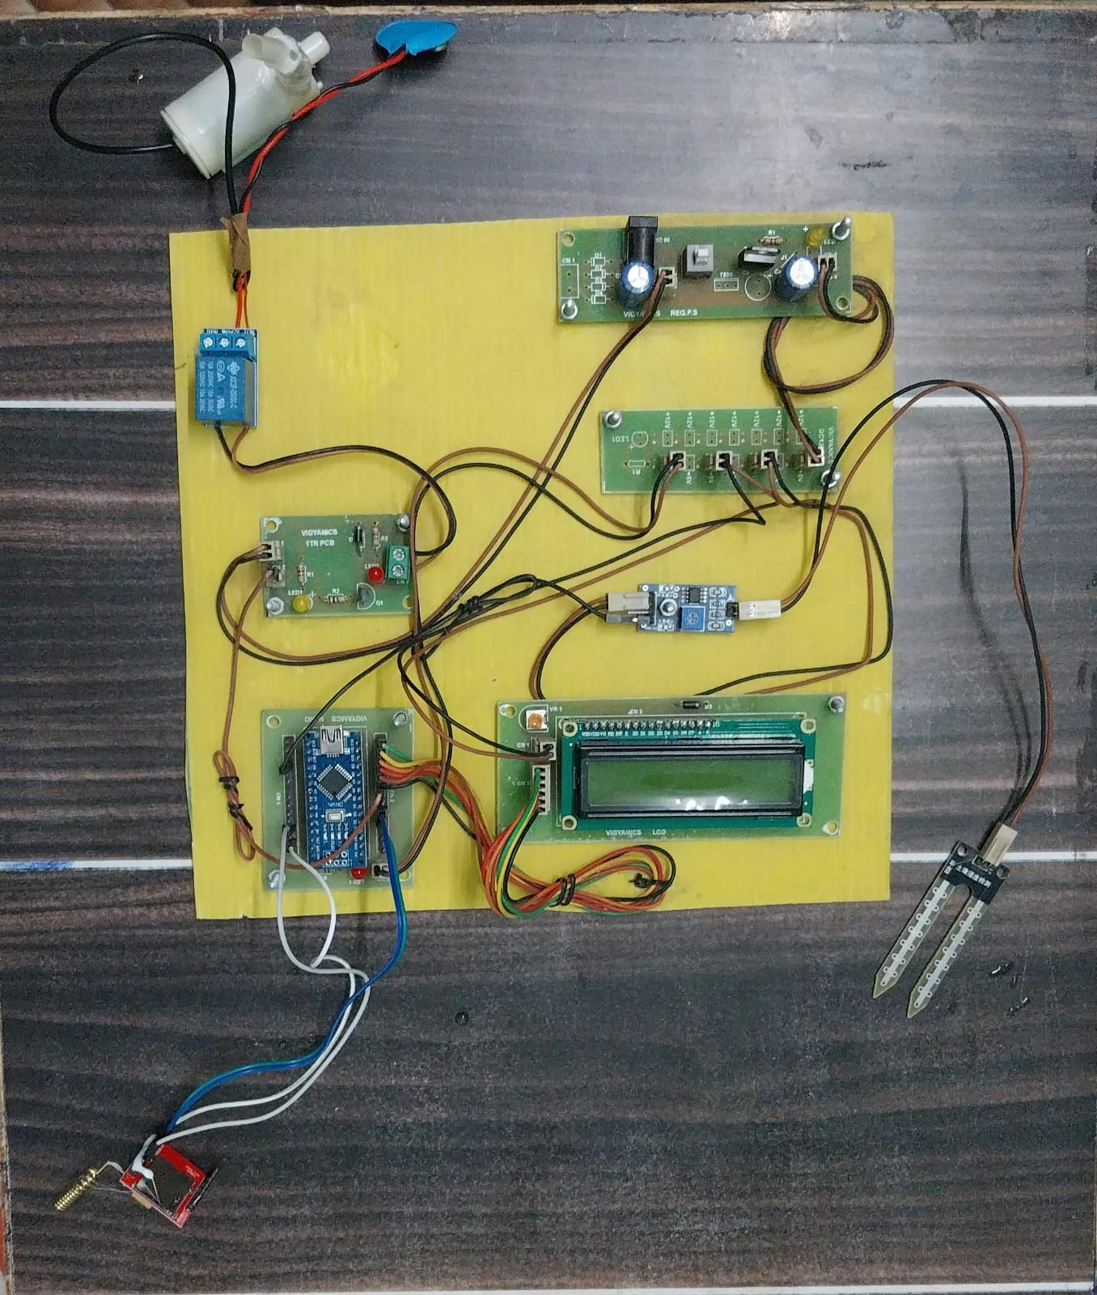

Procedure
- Hardware Setup
All the components including the Arduino Nano, soil moisture sensor, relay module, GSM module, LCD display, and water pump are connected according to the circuit design.
- Power Supply Initialization
The system is powered using an external power supply. The Arduino Nano receives power and initializes all connected devices.
- Sensor Initialization
The soil moisture sensor is inserted into the soil to measure the moisture level. The sensor continuously sends soil condition data to the Arduino Nano.
- Microcontroller Processing
The Arduino Nano reads the moisture values from the soil moisture sensor and compares them with a predefined threshold value programmed in the code.
- Dry Soil Detection
If the soil moisture level falls below the threshold (soil becomes dry), the Arduino Nano processes the signal and activates the relay module.
- Motor Pump Activation
The relay module turns ON the water pump motor, which starts supplying water to the irrigation system.
- Display Status on LCD
The LCD display shows the current system status such as “Motor ON” or “Motor OFF” to inform the user about irrigation activity.
- SMS Notification via GSM Module
The GSM module sends an SMS notification to the user's mobile phone informing them that the soil moisture is low and the motor pump has been turned ON.
- Moisture Level Monitoring
As water is supplied to the soil, the moisture sensor continuously monitors the updated soil moisture level.
- Motor Deactivation
When the soil moisture level reaches the normal range, the Arduino Nano deactivates the relay module.
- Pump Stops Water Supply
The relay turns OFF the water pump motor, stopping the irrigation process.
- Final Status Display and SMS Alert
The LCD display updates the status to “Motor OFF”, and the GSM module sends another SMS indicating that the soil moisture is now normal and irrigation has stopped.
- Continuous Monitoring
The system continues monitoring the soil moisture level and repeats the process whenever the soil becomes dry again.

Arduino Source Code
(The following code controls the irrigation system using soil moisture sensor and GSM module.)
#include<SoftwareSerial.h>
SoftwareSerial Serial1(2,3);
#include <LiquidCrystal.h>
LiquidCrystal lcd(12, 11, 10, 9, 8, 7);
int led=13;
int flag=0;
String str="";
#define motor 6
#define sensor A0
void setup()
{
lcd.begin(16,2);
Serial1.begin(9600);
Serial.begin(9600);
pinMode(led, OUTPUT);
pinMode(motor, OUTPUT);
pinMode(sensor, INPUT_PULLUP);
lcd.print("Water Irrigaton");
lcd.setCursor(4,1);
delay(2000);
lcd.clear();
lcd.setCursor(0,1);
lcd.print("Welcomes You");
delay(2000);
gsmInit();
lcd.clear();
lcd.print("System Ready");
}
void loop()
{
lcd.setCursor(0,0);
lcd.print("Automatic Mode ");
if(digitalRead(sensor)==1 && flag==0)
{
delay(1000);
if(digitalRead(sensor)==1)
{
digitalWrite(led, HIGH);
sendSMS("Low Soil Moisture detected. Motor turned ON");
lcd.begin(16,2);
lcd.setCursor(0,1);
lcd.print("Motor ON ");
digitalWrite(motor, HIGH);
delay(2000);
flag=1;
}
}
else if(digitalRead(sensor)==0 && flag==1)
{
delay(1000);
if(digitalRead(sensor)==0)
{
digitalWrite(led, LOW);
sendSMS("Soil Moisture is Normal. Motor turned OFF");
digitalWrite(motor, LOW);
lcd.begin(16,2);
lcd.print("Motor OFF");
lcd.setCursor(0,1);
lcd.print("Motor OFF");
delay(2000);
flag=0;
}
}
}
void sendSMS(String msg)
{
lcd.clear();
lcd.print("Sending SMS");
Serial1.println("AT+CMGF=1");
delay(500);
Serial1.print("AT+CMGS=");
Serial1.print('"');
Serial1.print("+917838340035");
Serial1.print('"');
Serial1.println();
delay(500);
Serial1.println(msg);
delay(500);
Serial1.write(26);
delay(1000);
lcd.clear();
lcd.print("SMS Sent");
delay(1000);
lcd.begin(16,2);
}
void gsmInit()
{
lcd.clear();
lcd.print("Finding Module..");
boolean at_flag=1;
while(at_flag)
{
Serial1.println("AT");
while(Serial1.available()>0)
{
if(Serial1.find("OK"))
at_flag=0;
}
delay(1000);
}
Serial1.println("ATE0");
lcd.clear();
lcd.print("Finding Network..");
boolean net_flag=1;
while(net_flag)
{
Serial1.println("AT+CPIN?");
while(Serial1.available()>0)
{
if(Serial1.find("READY"))
net_flag=0;
break;
}
delay(1000);
}
Serial1.println("AT+CNMI=2,2,0,0,0");
delay(1000);
Serial1.println("AT+CMGF=1");
delay(1000);
Serial1.println("AT+CSMP=17,167,0,0");
lcd.clear();
Serial1.flush();
}

Inputs
- Soil Moisture Sensor readings
- Power Supply
- GSM Network Connectivity

Outputs

- Automatic activation of water pump
- LCD display showing system status
- SMS notification to the user
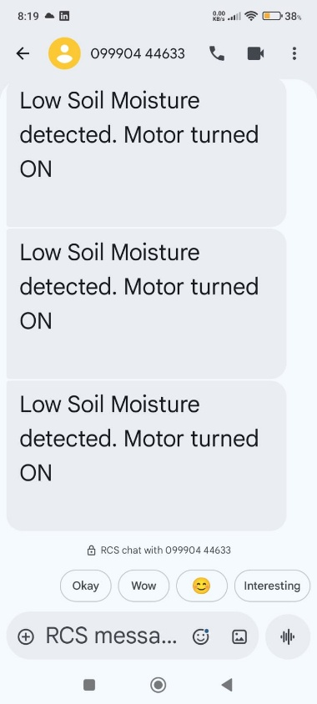
Results
The system successfully detects soil moisture conditions and automatically controls irrigation. SMS alerts are sent to inform the user whenever the motor is turned ON or OFF. This ensures efficient water management and reduces manual intervention.

Errors and Difficulties
- GSM module network detection sometimes takes time.
- Sensor calibration was required for accurate moisture detection.
- Delay in SMS sending due to network conditions.
- Initial wiring and hardware connections required troubleshooting.

Conclusion
The Smart Irrigation System demonstrates how IoT technology can be used in agriculture to automate irrigation. By using soil moisture sensors and GSM communication, the system ensures efficient water usage and reduces human effort. This project can be further improved by integrating cloud monitoring, AI-based prediction, and mobile applications for smart farming solutions.

